Hack-a-day Submission

I read the post earlier this year about the iPhone charger tear down. (http://hackaday.com/2012/05/20/iphone-charger-teardown-shows-astounding-miniaturization/) My favorite part of the article was the comparison between the $30 iPhone charger and a cheap/fake iPhone charger knock off. The article highlighted how important it is to verify products designed or assembled by overseas manufacturers.

Recently, I came across the following USB car charger from a Chinese manufacturer. One of our customers was ready to launch their USB powered product and purchased a few thousand pieces of the following car charger to include along with their product.

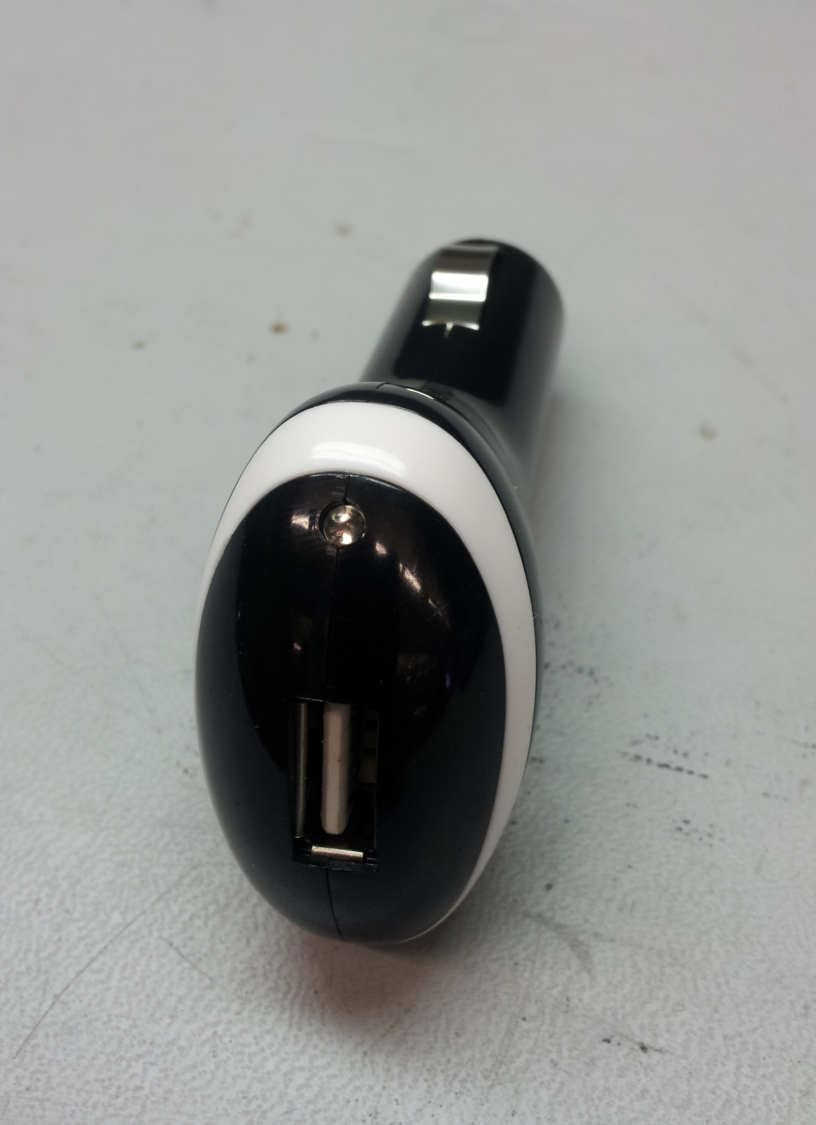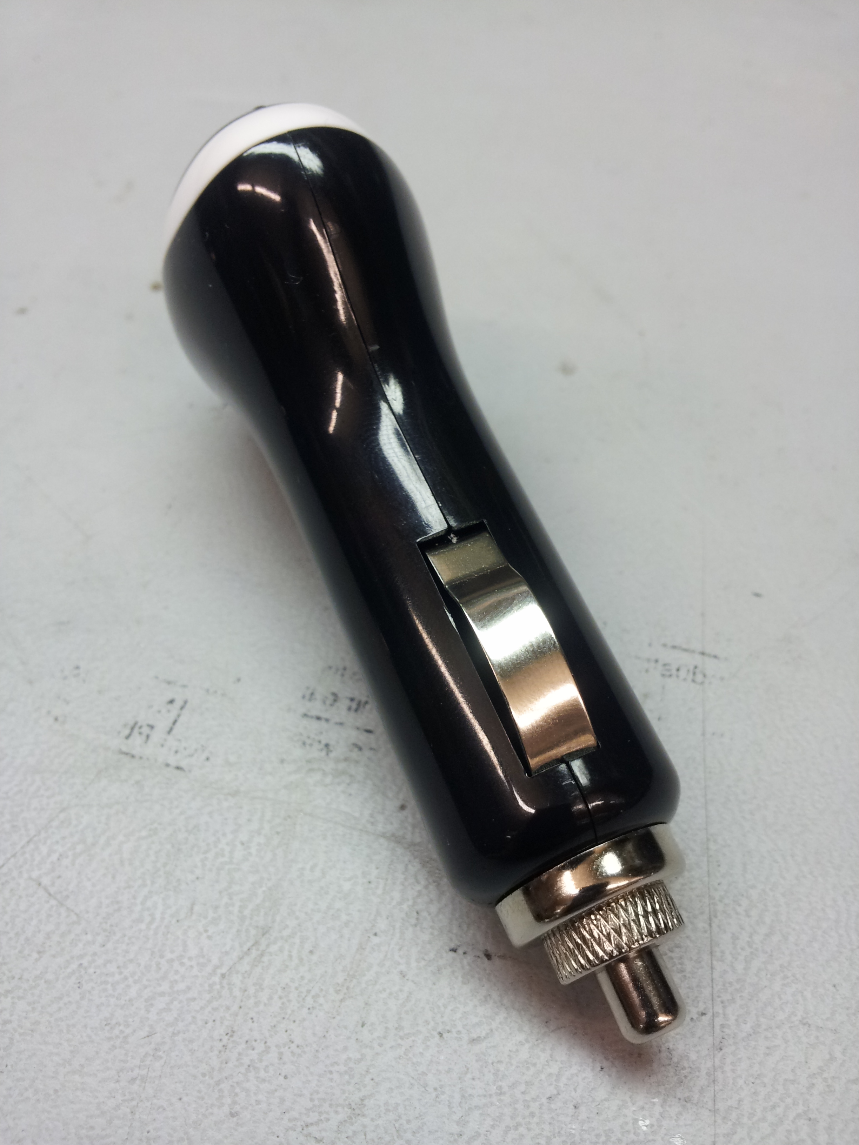

From the exterior, the 12V-USB converter appeared to be a good solution for the customer; however when a USB cable was plugged in to our prototype it immediately burned up our USB PHY. With some quick debugging it was determined that the internal voltage regulator within the 12V-USB converter must have shorted.

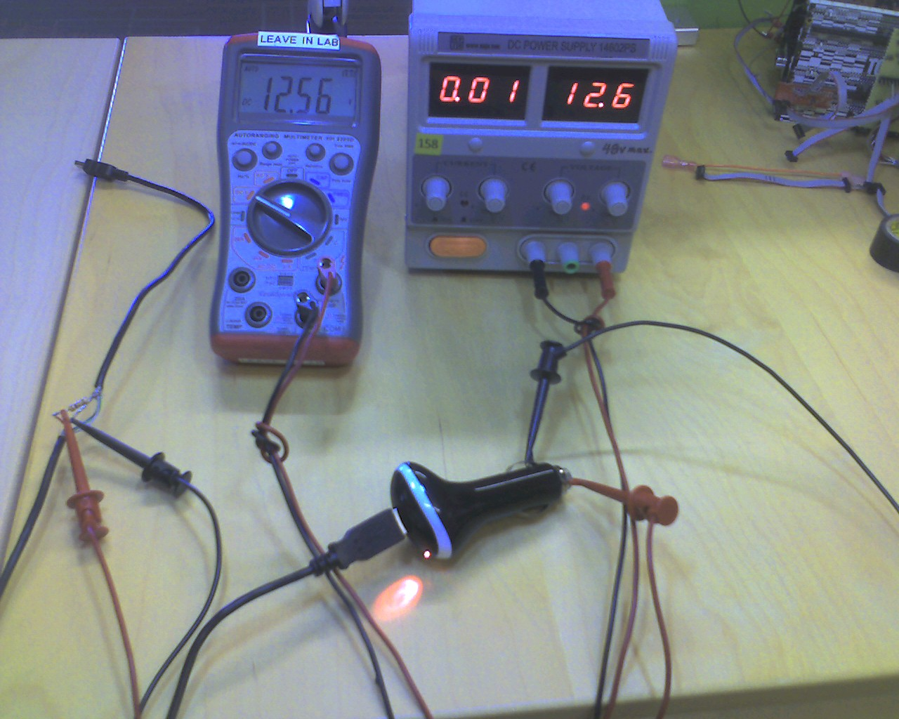

Instead, it turns out that the manufacturer never even populated the internal components in the switch mode regulators.

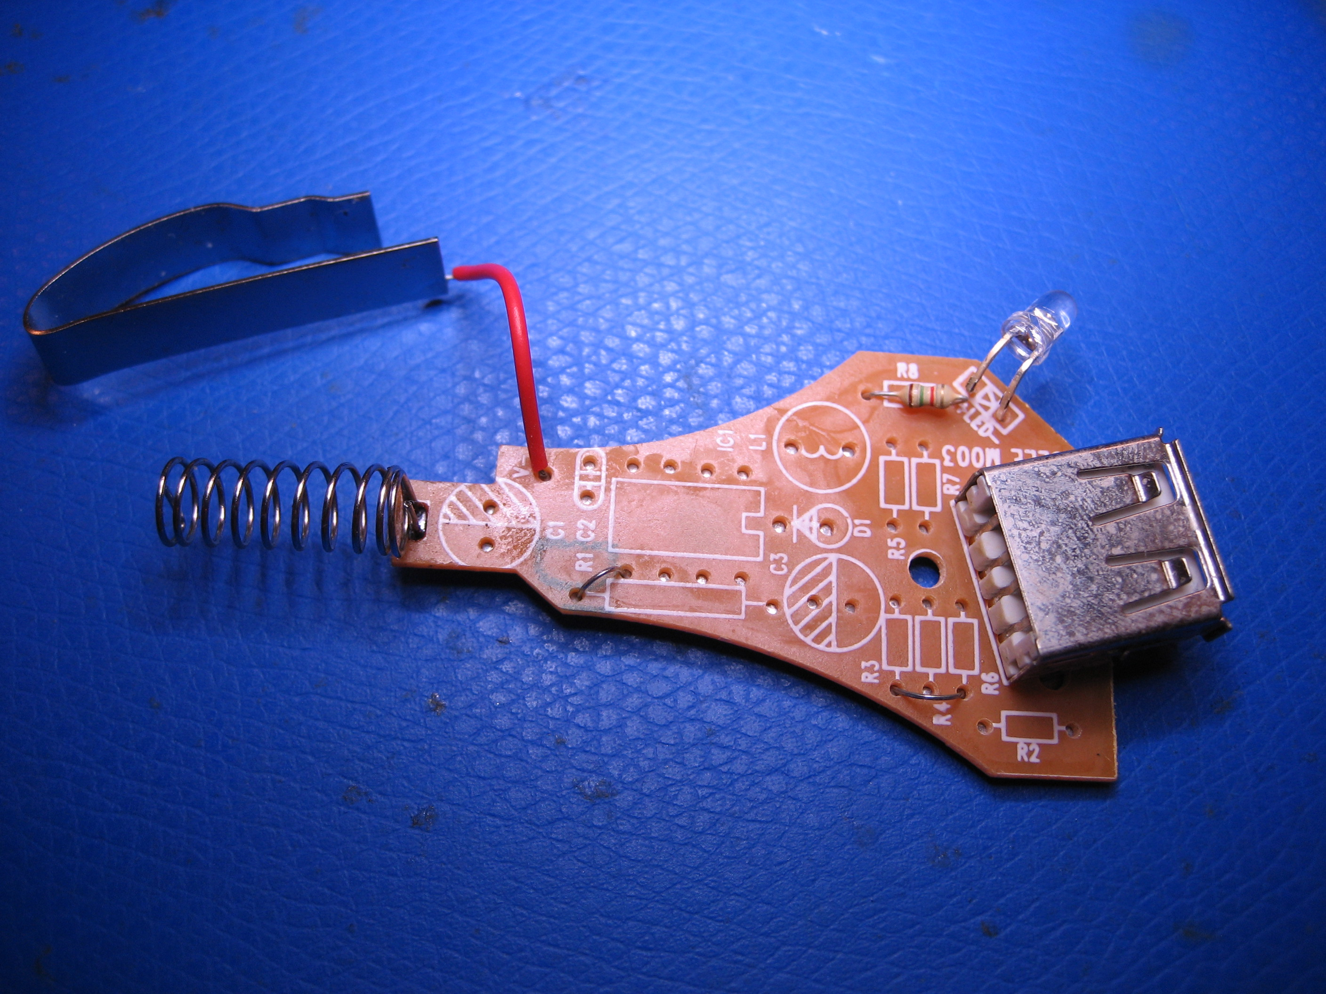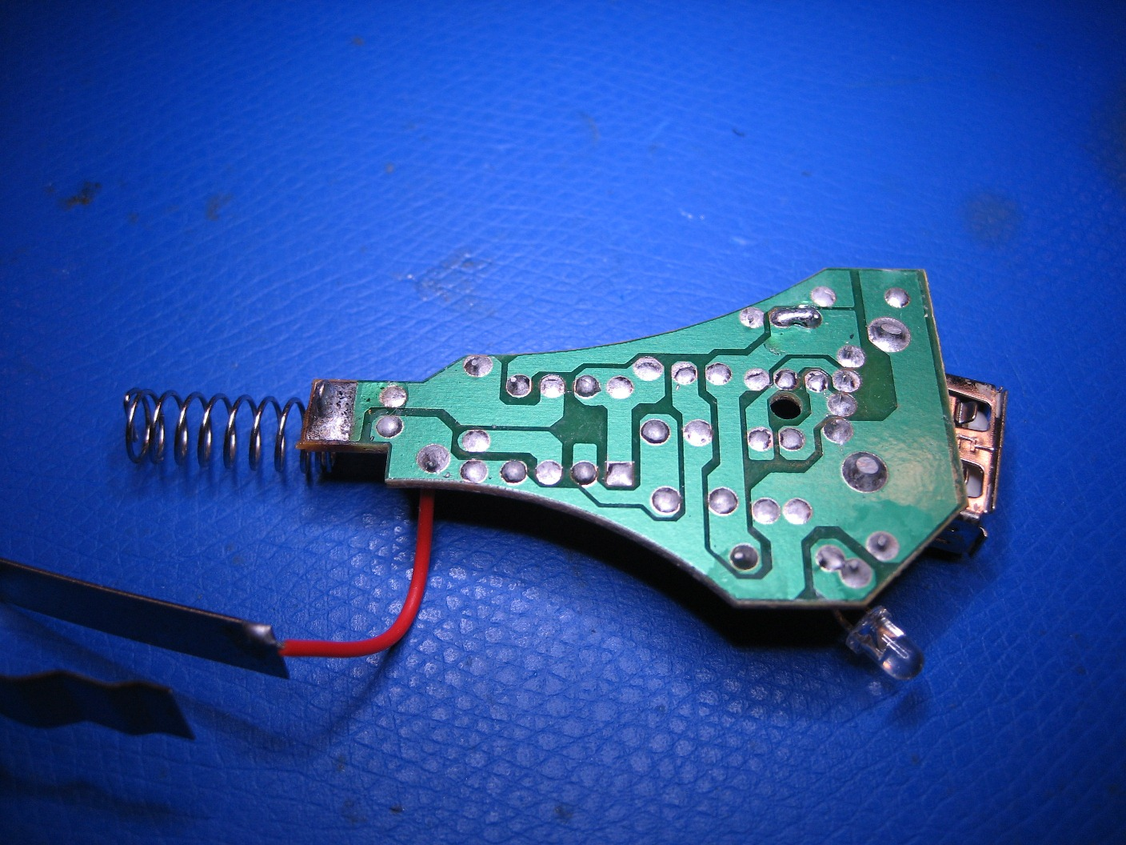

In summary, this serves as a quick reminder to always be careful with buying the ‘cheapest’ possible product from an overseas manufacturer in order to increase profit margins.

